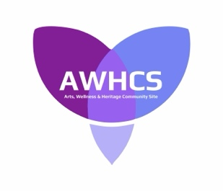

Press Release: Food and Book Sharing Pantry May 3, 2024

The Arts, Wellness and Heritage Community Site (AWHCS) group, in collaboration with the Portugal Cove-St. Philip’s Chamber of Commerce, are excited to announce an initiative that is ready for use by the citizens of PCSP.

1. A food and book sharing pantry has been constructed and installed just off the parking lot in front of the Old School House at 5 R.C. Church Drive, Beachy Cove Road.

2. Please give what you can and take what you need.

3. Users will notice there is a small mailbox on the side of the pantry. This is for your suggestions. Please let us know what your thoughts are for the use of the site.

4. In the coming months there will be several opportunities for the residents to engage with the AWHCS group about what their ideas are for this community site. There will be online surveys, workshops, etc. Please help us make this site and its use the very best it can be for everyone.

5. Please direct questions regarding the Food and Book Sharing Pantry to: awh-chair@nl.rogers.com

